- WIDE LOAD RESTRICTIONS [618] (ADDED 02-05-26 M)
Coordinate with the Project Manager for location and placement of the wide load restriction signs.
Furnish and install signs shown on the following detail, meeting the requirements of Detailed Drawing 618.01.
Route will specify the route number
Dir will specify the direction of the construction.
Mp will specify the milepost(s) of the work
Remove signs within 24 hours of removing the wide load restriction.
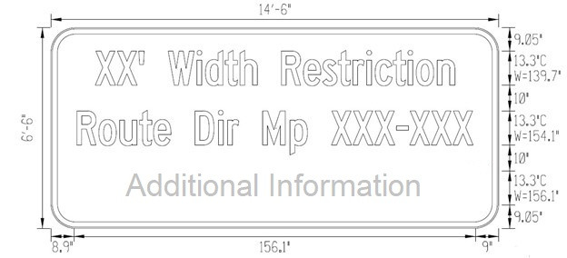
Sign information, if known:
XX’ Width Restriction
Route MP XXX -XXX
“Advise alternate Route”, “Info on 511MT.net”, or
“Additional Information:”

Sign Location | Location Description
sign location | location description

Wide load restriction signs will be measured and paid for as a Single Use Sign (SQFT). Cover the sign during winter suspension, if necessary.

