- WIDE LOAD ACCOMMODATIONS [618] (Revised 11-18-21 M)
Coordinate with the Project Manager to accommodate wide loads during construction. Provide passage of wide loads through the project area a minimum of 5 consecutive days/ week and two hours/day as approved by the Project Manager. Coordinate with the Project Manager to facilitate passage of wide loads on other projects on the same route or in proximity. Provide the Project Manager with the name and phone number of the person(s) to be contacted prior to wide loads arriving at the project site.
Place wide load detour signs at the following locations or as directed by the Project Manager. Furnish and install signs shown on the following detail, meeting Detailed Drawing 618-01. The ROUTE will specify the route number and MP will specify the milepost(s) of the work.

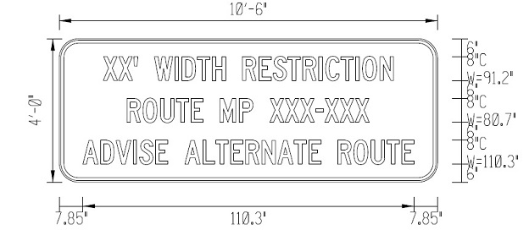
Sign information, if known:
XX’ Width Restriction
Route MP XXX -XXX
*Additional Information

Sign Location | Location Description
sign location | location description

Traffic control devices are paid for by lump sum or at the contract unit price per unit of traffic control devices. The units of each type of traffic control device paid for are calculated by multiplying the measured quantity of each device by the value per each unit shown in the traffic control rate schedule.
Wide load detour signs will be paid for as Single Use Signs (SQ FT). Cover the signs during the winter suspension if necessary. No separate payment will be made to cover wide load detour signs during winter suspension.

