MDT Structure ID
NBI Structure ID
Inspection Frequency
(6A) Feature Intersected
(7) Facility Carried
(9) Location
Latitude
Longitude
Inspection Procedures Update Info
Procedures Edited Date
Procedures Edited By
- FRACTURE CRITICAL (FC) INSPECTION PROCEDURE
Example:
- Review the following documents in SMS and discuss any questions with MDT:
  - FC inspection Procedure
  - Previous inspection report
  - Most recent underwater inspection report if applicable
  - Any other Special inspections or Repair items occurring since the most recent fracture critical inspection.
- Team leader holds a pre-inspection meeting to review procedure with team
- Notify MDT contact of anticipated inspection schedule
- Once team arrives onsite, team leader reviews safety risks and precautions with team before beginning inspection work.
- Traffic control set up
- Team members perform inspection roles as directed by team leader and according to FC inspection sequence:
- Once inspection of all elements is complete, Onsite QC review performed.
- Immediately notify MDT contact of any critical findings
- ON-SITE SAFETY RISKS AND PRECAUTIONS
Examples:
- Loose riprap at Abutment 2 is a falling hazard
- Poor vertical sight distance on approach to the North
- High voltage lines present onsite
- Small roadway shoulder provides poor parking and staging areas
- Wildlife (Osprey nest, or other?)
- TRAFFIC CONTROL MEASURES NEEDED

- EQUIPMENT NEEDED FOR ARM’S LENGTH INSPECTION OF FC MEMBERS
- MANPOWER NEEDED FOR ARM’S LENGTH INSPECTION OF FC MEMBERS

- STAGING AREAS AND ACCESS LOCATIONS
In addition to a written description, an aerial photo (i.e. Google Earth screenshot) is preferred
Example:
The gravel shoulder along the west approach roadway was used to park inspection vehicles and stage inspection equipment. Sight lines were good from both directions; however, caution should still be used. Advanced warning signage was placed approximately 100 yards from bridge in both directions.
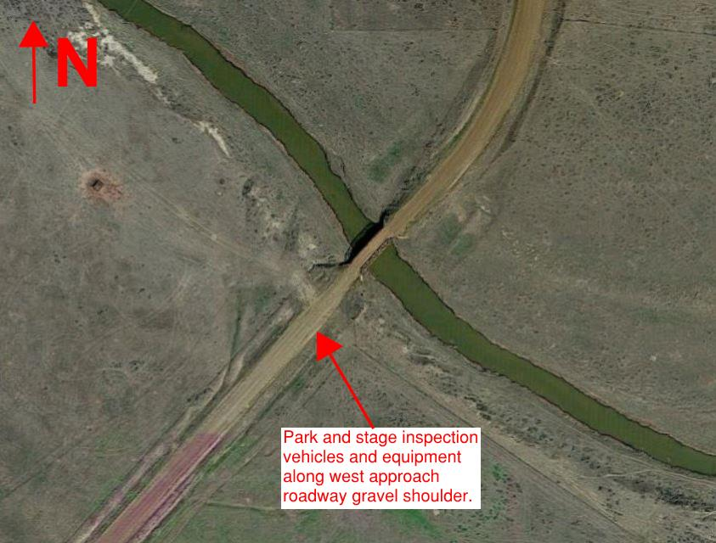
- NOTIFICATION REQUIRED FOR LOCAL AGENCIES
Examples:
No notification required for local agencies
Fresno Reservoir Spillway – contact BLM and Sherriff
Indian Reservations – detail applicable requirements (i.e. business license, work permits, timelines)
- PREVIOUS REPAIRS, RETROFITS, CRITICAL FINDINGS, AND FC RISK FACTORS
 | Risk Factor | Comment (required if risk factor is applicable)
 | Fatigue and fracture prone details
 | Problematic materials
 | Poor welding techniques
 | Potential out-of-plane distortion details
Previous cracking or repairs
Indicate source of prior cracking
 | Cold service temperatures
 | Superstructure condition of 4 or less
 | Subject to overloads or impact damage
 | Load posted
 | Older service life
 | Debris
 | High ADTT (i.e. ADTT > 5,000)
Example – if not captured above in the above table, include any issues noted during previous inspections as potential issues that should be closely inspected during subsequent inspection.
Additional factors identified as potential issues during previous inspections that should be closely inspected during subsequent inspections:
- GENERAL INSPECTION PROCEDURE COMMENTS
Examples:
- Describe any NDT testing techniques that are required (i.e. dye penetrant, magnetic particle, etc)
- Notes about bridge orientation/numbering (i.e. truss panel points are labeled West to East, L0 – L3 – L0’)
- Excessive bird dropping hinder adequate inspection of critical members. Contact MDT and recommend to removal/cleaning prior to inspection
- Utility pipe requires aid to climb around
- 4 floor beams and panel points are easily inspected from ground
- All floor beams require aid 6 times per floor beam
- Significant section loss to stringer ends. Start on stringer ends.
- FRACTURE CRITICAL MEMBER INSPECTION SEQUENCE
General sequence is acceptable, but it’s encouraged to include a more detailed sequence description if warranted by level of complexity.
Example (general sequence):
The following tasks should be performed as part of the bridge inspection:
- Mobilize to site and set-up signage at each end of the bridge to warn oncoming motorists.
- Hands-on inspection of all primary members in the plane of the primary truss lines, and secondary bracing member connections.
- Cursory inspection of secondary bracing members, with hands-on inspection of any noted deficiencies.
- Hands-on inspection of floor beams, floor beam-to-stringer connections, and stringer ends supported by substructure units. Cursory inspection of all other floor system elements.
- Inspection notes and photographs of any noted deficiencies
- Required photos of approaches, portal view, elevation view, underside of superstructure and any posting signs with bridge in background.
- Element level inspection and NBI inspection of approach spans and substructure elements
During the inspection, the bridge should be inspected for:
- Steel deficiencies including corrosion, section loss, cracking of welds or base metal, bolting or welding issues, and load induced distortion or damage
- Concrete deficiencies including delamination, spalls, patched areas, exposed rebar, cracking, abrasion, wear, and load induced distortion or damage
- Timber deficiencies including checking, splitting, decay or section loss, distortions, cracks, shakes, and abrasions
- Substructure deficiencies including wingwall tipping, settlement, and scour
- Bearing deficiencies including corrosion, connection issues, movement, alignment, loss of bearing area, and damage
- SKETCH OF BRIDGE WITH FRACTURE CRITICAL MEMBERS (FCM) IDENTIFIED IN RED
Show both truss elevation and floor system plan views. Two different examples shown below, either format is acceptable. Key things – make sure spans are labeled, indicate stream flow direction on floor system plan, only color present should be red to indicate fracture critical members. Please include a screenshot of the diagrams in the Inspection Procedures word document (rather than a separate document).
The following diagram shows all Fracture Critical Members (FCMs) in red. FCMs shall be inspected at arm’s length per FHWA Requirements:
Example #1:
Span 3 Truss Elevation

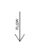
Span 3 Floor System

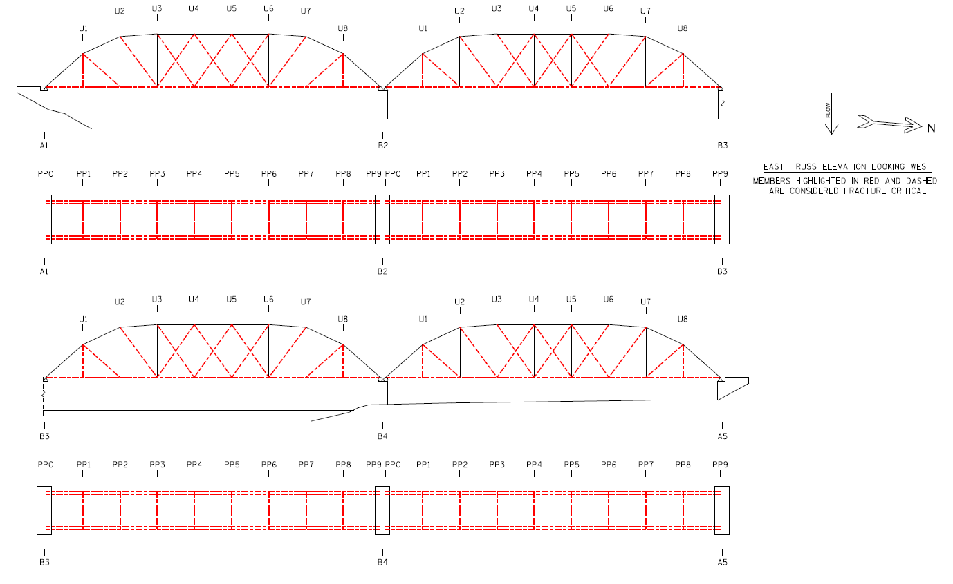
Example #2:
Span 1
Span 2
Span 3
Span 4

